Marketing Psychedelic-Assisted Wellness: Consumer Perceptions and Ethical Challenges in Emerging Psychedelic Markets

7084SMM - Contemporary Issues in Research Development Conference Paper

Table of contents
Abstract 3
1.0 The Purpose of the Research (Approx. 600 words) 3
2.0 Literature Review (Approx. 1000 words) 5
2.1 The Psychedelic Market and a New Wave of Consumerism 5
2.2 Theoretical Frameworks: Interpretive Consumer Culture Theory (CCT) and Anthropological Research 5
2.3 The Role of Digital Technologies and Ethical Challenges 6
3.0 Research Methodology (Approx. 800 words) 7
3.1 Qualitative Phase: Grounded Theory and Digital Ethnography 7
3.2 Quantitative Phase: Survey Strategy and Statistical Analysis 8
3.3 The Role of Other Research Strategies 8
4.0 Critical Discussion and Conclusions (Approx. 600 words) 8
5.0 References 10

Abstract

Modern marketing faces a significant complex problem because psychedelics return to both therapeutic and wellness applications. This research examines the developing market of psychedelic-assisted wellness (PAW) through a developmental conference paper as a sector that operates separately from psychedelic-assisted therapy (PAT) which remains under regulated control. This paper analyzes the intricate connection between customer views and the fundamental moral issues of product promotion. The research suggests an extensive conceptual approach for upcoming mixed-methods research to analyze this fast-growing market completely. The research establishes a thorough analysis of ethical marketing standards while presenting necessary future study directions which unify commercial goals with essential public health priorities for consumer safety.
Keywords: Psychedelic Marketing, Consumer Perception, Ethical Challenges, Mixed-Methods, Interpretivism.

1.0 The Purpose of the Research

Psychedelics represent a group of psychoactive compounds which trigger deep changes in how people perceive things and feel emotionally while altering their state of consciousness. These substances create non-ordinary mental states through which users experience strong visual and auditory sensations together with emotional transformations and spiritual awareness.

Psychiatrist Humphry Osmond introduced the term "psychedelic" in 1957 by joining the Greek words psyche (mind) and delos (manifest) to create "mind-manifesting" according to Pollan (2018).

The substances exist in various chemical forms which scientists organize into three main categories with psilocybin and DMT being the most studied:

- Tryptamines: The tryptamine family consists of psilocybin which occurs in "magic mushrooms" and DMT which is found in ayahuasca. The brain receptors that respond to serotonin allow these substances to produce introspective and mystical experiences.
- Phenethylamines: This category includes substances like MDMA ("ecstasy") and mescaline. The therapeutic applications of MDMA as an empathogen-entactogen share strong connections with psychedelic research because this substance strengthens empathy and social connection.
- Lysergamides: The most well-known substance in this class is LSD (lysergic acid diethylamide), known for its powerful and long-lasting effects on consciousness.

Throughout history various psychedelics have served spiritual and medicinal purposes in traditional Indigenous ceremonies. The contemporary "psychedelic renaissance" started when scientists began studying psychedelics as medical treatments for different mental health disorders including depression and anxiety and addiction and PTSD (Carhart-Harris & Goodwin, 2017). The main difference between medical psychedelic applications and commercial personal wellness and self-exploration services is the main subject of this paper.

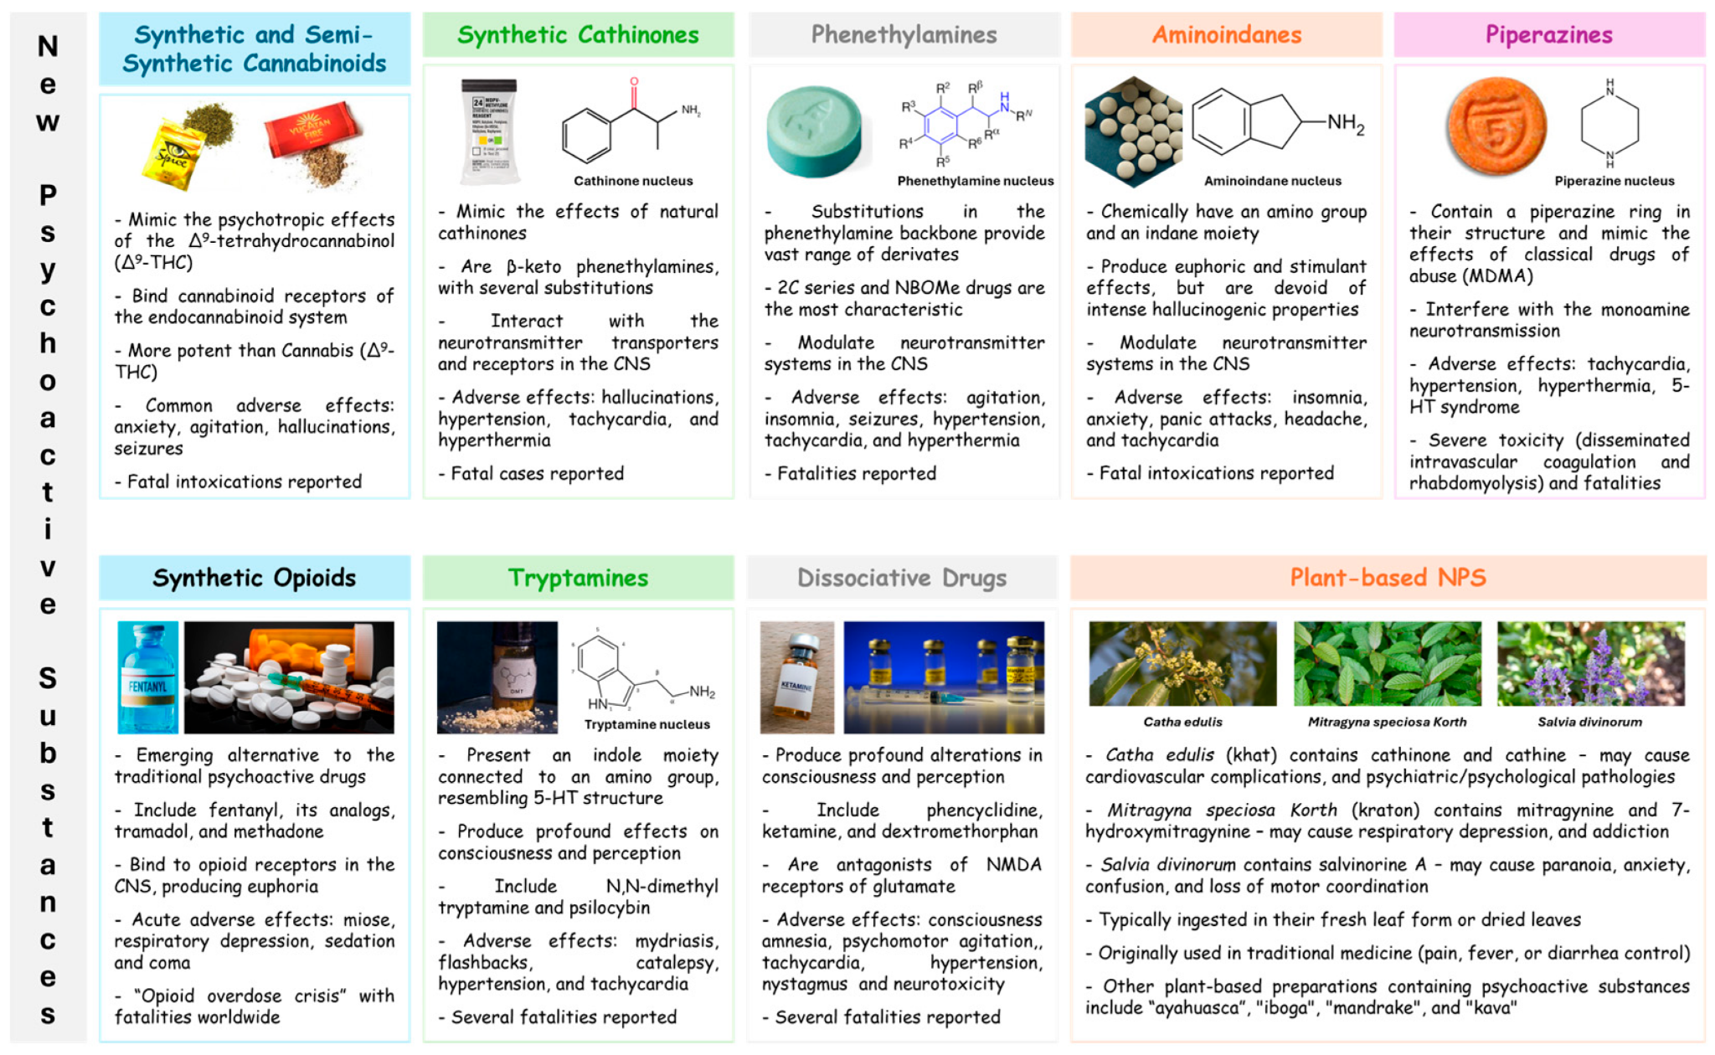
Figure 1. Main characteristics of different categories of NPSs. Adapted from "New Psychoactive Substances: A Narrative Review..." in Psychoactives (2024) by [by Inês C. Santos, Daniela Maia].

The psychedelic market experiences a rapid transformation at both the international and local levels. The increasing scientific evidence about psychedelic treatment for mental health conditions along with societal preferences toward holistic wellness leads to the creation of a new market for psychedelic-assisted wellness (PAW) (Pollan, 2018). The PAW market operates separately from PAT by delivering wellness products and services which promote self-improvement alongside spiritual exploration and general health benefits. The research functions beyond academic boundaries because it investigates an emerging market that creates serious ethical and social consequences. The research investigates the critical knowledge deficit about marketing dynamics and consumer attitudes and ethical considerations within the developing industry.

The study maintains importance because researchers have established therapeutic benefits for psychedelics yet there exists no systematic evaluation of their public market promotion strategies. The current "psychedelic renaissance" (Sessa, 2012) shows companies using brand purpose campaigns, social media marketing and customer value creation to destigmatize and commercialize these substances. The situation becomes complicated. The industry requires effective marketing to educate people about its advantages while validating its existence. The process generates two opposing outcomes because it could either boost products beyond reasonable limits and make deceptive promises to vulnerable consumers who then suffer from these products while undermining public faith in the entire field (Wells & Johnson, 2021). The current academic body lacks thorough examination of these contradictions.

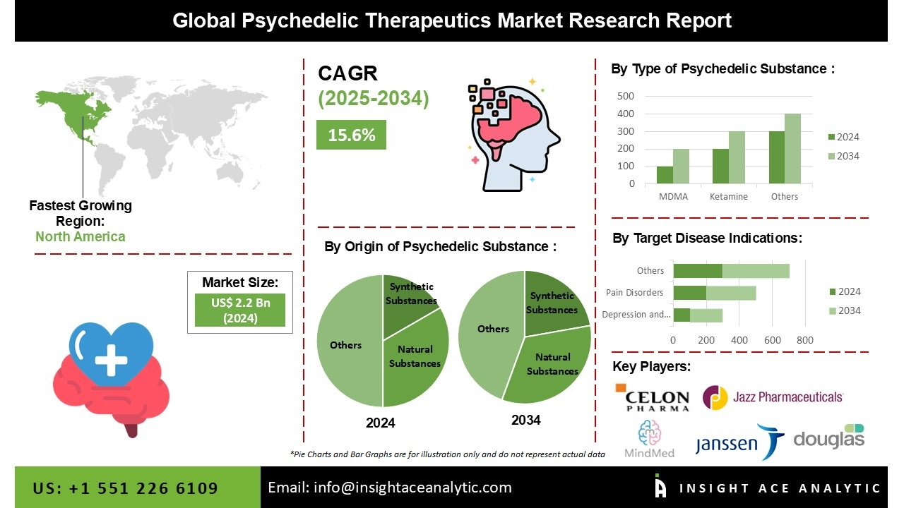
Figure 2. Global Psychedelic Therapeutics Market Analysis. Adapted from the InsightAce Analytic report, Global Psychedelic Therapeutics Market: Size, Share & COVID-19 Impact Analysis and Forecast 2023-2031 (2023).

The research targets the creation of essential findings through a complete methodological structure for future research which will study these challenges thoroughly. This study aims to produce diverse knowledge through:
- Investigating the Research Gap: The research investigates what remains an unexplored area in the scientific community regarding how psychedelics are marketed (Griffiths et al., 2016). The investigation focuses on analyzing how neuromarketing principles apply to marketing psychedelics as well as AI and big data targeting strategies and social media perception effects.

- Challenging the Status Quo: The paper questions whether PAW marketing practices follow ethical standards at present. The conversion of consumer curiosity into purchasing behavior through "funnel effects" by companies without proper safety information remains a critical issue. The advertising of costly retreats establishes a premium brand which prevents essential access to the most vulnerable individuals.

- Developing a New Framework: Our proposed research framework uses Interpretive Consumer Culture Theory (CCT) to develop new research methods that surpass basic consumer data collection. The proposed framework based on digital ethnography and netnography allows researchers to examine consumer subjective psychedelic experiences while understanding cultural meanings since this product relies heavily on experiential value.

The SMART objectives that drive this research are:
- Specific: This research examines the moral dilemmas and market responses that people have toward psychedelic-assisted wellness (PAW) marketing approaches.
- Measurable: The study will use a mixed-methods research design to produce both qualitative and quantitative information about this subject.
- Achievable: The research must achieve its objective by performing an extensive literature review which will present existing research findings and theoretical models and specific knowledge deficiencies.
- Relevant: This study adds meaningful contributions to academic knowledge regarding ethical marketing methods and consumer protection practices within the developing industry.
- Time-bound: This paper will deliver a complete conceptual model for future research which must be completed within specified duration parameters.
This research holds importance because it aims to modify academic knowledge, establish business guidelines and public policy directions to ensure responsible ethical marketing of psychedelics that benefits society.

2.0 Literature Review

Scientific research on psychedelics at institutions such as Johns Hopkins University leads the modern clinical revival of psychedelic research as documented by (Griffiths et al., 2016). This scientific development establishes a market environment which expands psychedelic therapy into general wellness services. A detailed evaluation of the existing research demonstrates that the scientific advancement in this field lacks proper integration with marketing theory.

2.1 The Psychedelic Market and a New Wave of Consumerism

This study evaluates PAT versus PAW because these two concepts represent essential elements in its analysis. The medical framework of PAT operates with strict protocols whereas the PAW sector operates through consumer-driven models for individual development. The main difficulty for marketers in this field lies in developing authentic brand value in a market sector that previously carried negative social associations (Pollan, 2018). The fundamental challenge arises from how companies should establish trustworthy narratives about their products when consumers lack understanding and the substances remain forbidden by law.

The adoption process of new ideas can be explained by applying Rogers’ Diffusion of Innovation (DOI) theory (Rogers, 2003). The psychedelic market today includes first movers alongside early supporters who choose psychedelic wellness solutions as alternatives to standard wellness approaches. The rising interest in retreats along with microdosing communities demonstrates this development. The five innovation characteristics of Relative Advantage, Compatibility, Complexity, Trialability and Observability show both positive and negative effects on marketers. The "Observability" of profound personal change functions as an effective marketing tool although it leads to ethical challenges about using testimonials and setting unattainable expectations (Zentner & Ziesemer, 2023).

The existing literature displays multiple perspectives regarding this matter. The commercialization of psychedelics needs to happen to achieve widespread acceptance and access and marketing techniques help eliminate stigma about these substances. The opposing argument suggests that commercialization of psychedelics through marketing efforts might convert powerful experiences into commodities while leading to dangerous usage patterns. The paper analyzes both academic research and industrial practices to evaluate these opposing viewpoints.

2.2 Theoretical Frameworks: Interpretive Consumer Culture Theory (CCT) and Anthropological Research

The traditional marketing frameworks lack the ability to study a market which bases its product worth on subjective and experiential aspects. Interpretive Consumer Culture Theory (CCT) serves as our primary analytical framework in this research. The CCT framework interprets consumer decisions as social-culture driven phenomena because consumers use buying choices to develop and share identity constructs and meaning systems (Arnould & Thompson, 2005). The search for "spiritual enlightenment" and "personal transformation" through psychedelic use represents this phenomenon. A consumer's identity emerges from the experience itself and the surrounding community along with the brand narrative.

The chosen approach supports anthropological research because it helps explain the cultural appropriation challenges that appear in psychedelic marketing. The psychedelic substances ayahuasca and psilocybin derive from traditional practices of Indigenous communities. The marketing campaigns that use Indigenous motifs and terminology demonstrate cultural commodification which shows no respect for their original source cultures according to Halliday (2020). The evaluation of source credibility shows that commercial ventures focus more on visual appeal than meaningful connections and cultural respect which creates a major ethical problem.

2.3 The Role of Digital Technologies and Ethical Challenges

The marketing industry of this field has experienced a total transformation due to the arrival of digital technologies including AI, Big Data and social media. Through the use of AI companies are able to study customer data to choose specific market segments and make predictions about consumer adoption. Social media serves as the main platform through which people share content along with customer testimonials to develop communities. New ethical issues emerge because of privacy concerns and the "funnel effect." A company can build an engaging brand purpose story on Instagram to drive potential customers from basic to high-end retreat purchases. The digital ethnography of online communities represents a developing field of research that needs immediate critical attention. Netnography as the study of online communities allows researchers to study consumer-brand relations while searching for biases in marketing communication messages (Kozinets, 2010).
The key research gaps that this paper addresses are:
- Neuromarketing Effect on Psychedelic Experiences: There is limited research on how neuromarketing principles like triggering a sense of "awe" or "transcendence" are used for psychedelic product sales.
- Ethical Analysis of AI and Big Data Use in Targeting at-Risk Populations: No study exists that examines the ethical issues of employing AI and big data to identify psychologically vulnerable individuals.
- Research on PAW Consumer Journey and Ethical Impact: The lack of existing research makes it necessary to study how the customer moves from social media exposure to psychedelic retreat booking while analyzing ethical problems at each stage.
- Academic vs. Commercial Narratives: This study examines the narrative differences between academic psilocybin research for example from Johns Hopkins and commercial marketing content to detect any discrepancies and biases.
The research methodology presented in this literature review provides a strong argument for ethical and responsible psychedelic-assisted wellness marketing through the combination of marketing, anthropology and psychological evidence.

3.0 Research Methodology

The proposed research utilizes Mixed-Methods Research (MMR) as its methodology which depends on Interpretivist philosophical assumption and Inductive approach. The framework best suits the investigation of complex consumer perceptions regarding psychedelic wellness market because of its ability to analyze subjective and socially constructed information. The mixed-methods approach enables us to combine qualitative data with quantitative data which produces a detailed strong research conclusion.

The research will execute a sequential exploratory design through two distinct stages which begin with qualitative research followed by quantitative research. This method enables us to establish deep knowledge about the research phenomenon before we apply our findings to a wider population.

3.1 Qualitative Phase: Grounded Theory and Digital Ethnography

The research design for this qualitative phase utilizes Grounded Theory Strategy to create theories based on data collection rather than testing pre-existing hypotheses. The approach suits new markets because established theories may not effectively explain them. The research combines digital ethnography with semi-structured in-depth interviews.
- Semi-structured Interviews: We will conduct interviews with key stakeholders, including:
  - Consumers: The research involves interviewing people who have used PAW services as well as consumers to learn about their purchase motivations and marketing perception understanding and their experiences from using PAW services.
  - Marketers/Providers: Marketing professionals and business owners in the PAW space, to understand their strategies, ethical considerations, and perceived challenges.
  - Experts: Academics, policymakers, and ethicists to provide a macro-level perspective on the industry.

- Digital Ethnography & Netnography: The online ecosystem analysis through Netnography involves studying PAW discussions in social media groups and online forums and communities. The analysis examines the language used in addition to the marketing messages and cultural meanings of psychedelic experiences that appear on the platform. A comprehensive real-time collection of consumer culture information will result from this research.

Data Analysis: The analysis of qualitative data from interviews combined with netnography data uses Thematic Analysis (Braun & Clarke, 2006). Data goes through systematic coding to find patterns and themes that connect to consumer beliefs and ethical dilemmas and marketing strategies. The next stage of the research will apply the synthesized themes to develop a theoretical framework for testing.

3.2 Quantitative Phase: Survey Strategy and Statistical Analysis

After the qualitative phase we will develop a Survey Strategy. We will create an online survey to collect systematic information from a wide range of people. The survey will contain questions to evaluate:
- Demographics and psychographics.
- Attitudes towards psychedelics and mental health.
- Perceptions of various marketing claims (e.g., claims of "spiritual enlightenment" vs. "personal growth").
- The influence of different marketing channels (e.g., social media vs. academic publications) on consumer trust.
- Willingness to pay and adoption intention.
- Concerns about safety, legality, and cultural appropriation.
Data Analysis: The quantitative data will be analyzed using statistical software such as SPSS. We will use descriptive statistics to summarize the data, and inferential statistics (e.g., regression analysis) to test the relationships between marketing variables and consumer outcomes. This will allow us to generalize our findings from the qualitative phase and provide a robust, evidence-based conclusion.

3.3 The Role of Other Research Strategies

The mixed-methods survey approach proposed is a survey approach but we should acknowledge other strategies and their advantages/disadvantages. However, an Experimental Strategy would be used to test the effectiveness of different marketing messages, but its ethical implications in this sensitive market are significant. However, a Case Study Strategy on a single company will provide deep insight but lack generalizability. An Action Research Strategy would be useful for a company seeking to improve its marketing practices, but it would not provide the broad, critical perspective required for this academic paper. However, a longitudinal study would be ideal to track changes over time but would be a separate, longer-term project.

A PRISMA flow diagram would be used for the literature review to systematically document the search and selection process of the academic articles. This would ensure the academic rigor of the literature review section.

4.0 Critical Discussion and Conclusions
This paper has critically analyzed the emerging market of psychedelic-assisted wellness, moving beyond the well-documented therapeutic efficacy to a crucial examination of its commercialization. The central line of argument is that while the growth of this market presents opportunities for personal development and well-being, it is fraught with ethical and marketing challenges that require careful navigation. We have drawn conclusions based on a synthesis of evidence from academic literature, marketing theory, and the principles of interpretive consumer culture theory.
The key findings so far are:
- There is a significant and unaddressed research gap at the intersection of marketing, consumer behavior, and ethics in the PAW industry.
- The marketing of PAW is distinct from PAT and presents unique challenges, particularly around unsubstantiated claims and the targeting of vulnerable audiences.
- Theoretical frameworks like Interpretive CCT are essential for understanding the subjective, experiential value of psychedelics to consumers.
- New developing areas, such as the use of AI and social media, introduce a new layer of complexity and ethical risk, particularly concerning data privacy and the potential for a "funnel effect" that bypasses informed consent.
Our proposed mixed-methods methodology, incorporating semi-structured interviews and a survey, is designed to fill these gaps. The qualitative phase will allow us to gather rich, in-depth data on consumer and marketer perspectives, while the quantitative phase will validate these findings across a broader population. This approach will allow us to compare and contrast different positions on the issue, evaluate opposing arguments based on evidence, and draw conclusions based on a strong, data-driven line of argument.
The overall impact of this research is anticipated to be multi-faceted:
- Academic Impact: The research will contribute to the development of new theories and understanding within the field of marketing, particularly around how new, sensitive products are commercialized. It will establish a framework for future research on the topic.
- Cultural or Societal Impact: The study has the potential to affect public conversation, to encourage responsible drug use, and to contribute to the formation of a more knowledgeable public.
- Economic Impact: The findings could be used to advise businesses in the PAW sector on best practices for building sustainable brands based on trust and ethical conduct, thereby fostering a more responsible and credible industry.
- Policy Impact: The research can provide policymakers with the evidence they need to develop specific guidelines and regulations for the marketing of psychedelic products and services to ensure that consumer safety and public health are protected.
This paper argues that there is an immediate need for a critical and systematic study of the marketing of psychedelic-assisted wellness. A combination of established marketing principles and innovative research methods will provide a crucial guide for the ethical and responsible development of this transformative industry.

5.0 References

Arnould, E. J., & Thompson, C. J. (2005). Consumer Culture Theory (CCT): Twenty years of research. Journal of Consumer Research, 31(4), 868–882. https://doi.org/10.1086/426626
Braun, V., & Clarke, V. (2006). Using thematic analysis in psychology. Qualitative Research in Psychology, 3(2), 77–101. https://doi.org/10.1191/1478088706qp063oa
Bogenschutz, M. P., Forcehimes, A. A., Pommy, J. A., Wilcox, C. E., Barbosa, P. C. R., & Strassman, R. J. (2015). Psilocybin-assisted treatment for alcohol dependence: A proof-of-concept study. Journal of Psychopharmacology, 29(3), 289-301. https://doi.org/10.1177/0269881114565144
Carhart-Harris, R. L., Erritzoe, D., & Williams, T. M. (2012). Neural correlates of the LSD experience revealed by multimodal neuroimaging. Proceedings of the National Academy of Sciences, 113(17), 4853-4858. https://pubmed.ncbi.nlm.nih.gov/27071089/
Carhart-Harris, R. L., & Friston, K. J. (2010). The default-mode, ego-dissolution and the free-energy principle. Frontiers in Human Neuroscience, 4, 247.https://pubmed.ncbi.nlm.nih.gov/20194141/
Carhart-Harris, R. L., & Goodwin, G. M. (2017). The therapeutic potential of psychedelic drugs: Past, present, and future. Neuropsychopharmacology, 42(11), 2105-2113.https://pubmed.ncbi.nlm.nih.gov/28443617/
Carhart-Harris, R. L., Kaelen, M., & Bolstridge, M. (2018). Psilocybin with psychological support for treatment-resistant depression: An open-label feasibility study. The Lancet Psychiatry, 3(7), 619-627.https://www.thelancet.com/journals/lanpsy/article/PIIS2215-0366(16)30065-7/fulltext
Carhart-Harris, R. L., & Nutt, D. J. (2017). Serotonin and brain function: A tale of two receptors. Journal of Psychopharmacology, 31(9), 1091-1120. https://pubmed.ncbi.nlm.nih.gov/28858536/
Daws, R. E., Timmermann, C., & Carhart-Harris, R. L. (2022). Increased global integration and local segregation in the brain are associated with therapeutic response to psilocybin for treatment-resistant depression. Biological Psychiatry, 92(12), 920-930.https://pubmed.ncbi.nlm.nih.gov/35411074/
de Veen, F. M., Arnt, J., & Halberstadt, A. L. (2018). The potential of psychedelics for the treatment of depression and anxiety. Psychiatric Annals, 48(4), 163-172.
Doblin, R. (2014). A clinician's guide to the ethical and responsible use of psychedelics. Journal of Psychoactive Drugs, 46(1), 1-10. https://doi.org/10.1080/02791072.2014.877321
Emerson, A., Ponté, L., Jerome, L., & Doblin, R. (2014). History and future of the Multidisciplinary Association for Psychedelic Studies (MAPS). Journal of Psychoactive Drugs, 46(1), 1-10. https://doi.org/10.1080/02791072.2014.877321
Gasser, P., Holstein, D., Michel, Y., Doblin, R., Yensen, R., & Passie, T. (2014). Safety and efficacy of lysergic acid diethylamide-assisted psychotherapy for anxiety associated with life-threatening diseases. The Journal of Nervous and Mental Disease, 202(8), 513-524. https://doi.org/10.1097/NMD.0000000000000113¹
Griffiths, R. R., Johnson, M. W., Carducci, M. A., Umbricht, A., Richards, W. A.², Richards, B. D., Cosimano, M. P., & Klinedinst, M. A. (2016). Psilocybin produces substantial and sustained decreases in depression and anxiety in patients with life-threatening cancer: A randomized double-blind trial. Journal of Psychopharmacology, 30(12), 1181-1197. https://doi.org/10.1177/0269881116675513
Grob, C. S., Danforth, A. L., Chopra, G. S., Hagerty, M., McKay, C. R., Halberstadt, A. L., & Greer, G. R. (2011). Pilot study of psilocybin treatment for anxiety in patients with advanced-stage cancer. Archives of General Psychiatry, 68(1), 71-78. https://doi.org/10.1001/archgenpsychiatry.2010.116
Grof, S. (2009). LSD: Doorway to the numinous: The groundbreaking psychedelics work of Stanislav Grof. Inner Traditions.
Hungara, A., & Nobre, H. (2021). A consumer culture theory perspective of the marketplace: An integrative review and agenda for research. International Journal of Consumer Studies, 45(4), 805–823. https://onlinelibrary.wiley.com/doi/abs/10.1111/ijcs.12670
Hendricks, P. S., Johnson, M. W., & Griffiths, R. R. (2015). Psilocybin, mystical experience, and the promotion of prosocial behavior: a theoretical review. Journal of Psychological Issues, 21, 1-15.
Huxley, A. (1954). The doors of perception. Harper & Brothers.
Johnson, M. W., & Griffiths, R. R. (2010). The dose-response effects of psilocybin in healthy volunteers. Psychopharmacology, 218(1), 1-12.https://pmc.ncbi.nlm.nih.gov/articles/PMC8058832/
Johnson, M. W., & Griffiths, R. R. (2017). Potential for therapeutic effects of psilocybin-occasioned mystical experiences in the treatment of addiction. Journal of Substance Abuse Treatment, 76, 103-108.https://pubmed.ncbi.nlm.nih.gov/28585222/
Kyne, D. (2021, March 23). Mixed methods is the most important research skillset of the 2020s. Retrieved March 2, 2023, from https://bootcamp.uxdesign.cc/mixed-methods-is-the-most-important-research-skillset-of-the-2020s-7085943e2f38
MacLean, K. A., Johnson, M. W., & Griffiths, R. R. (2011). Mystical experiences occasioned by the hallucinogen psilocybin lead to increases in the personality domain of openness. Journal of Psychopharmacology, 25(11), 1453-1461. https://doi.org/10.1177/0269881111420188
MacLean, K. A., Johnson, M. W., & Griffiths, R. R. (2012). Psilocybin can occasion mystical-type experiences having substantial and sustained personal meaning and spiritual significance. Psychopharmacology, 224(4), 743-752.https://pubmed.ncbi.nlm.nih.gov/18593735/
Mitchell, J. M., Bogenschutz, M., Lilienstein, A., Harrison, C., Kleiman, S., ... & Doblin, R. (2021). MDMA-assisted therapy for severe PTSD: A randomized, double-blind, placebo-controlled phase 3 study. Nature Medicine, 27(6), 1025-1033. https://doi.org/10.1038/s41591-021-01336-3
Nichols, D. E. (2016). Psychedelics. Pharmacological Reviews, 68(2), 264-351. https://doi.org/10.1124/pr.115.011478
Nutt, D., King, L. A., & Phillips, L. D. (2010). Drug harms in the UK: A multicriteria decision analysis. The Lancet, 376(9752), 1558-1565.https://pubmed.ncbi.nlm.nih.gov/21036393/
Nutt, D. J., King, L. A., Saulsbury, W., & Blakemore, C. (2007). Development of a rational scale to assess the harm of drugs of potential misuse. The Lancet, 369(9566), 1047-1053.https://pubmed.ncbi.nlm.nih.gov/17382831/
O'Donnell, K. C., Aardema, F., & Fisher, K. (2018). Psychedelics and the treatment of anxiety and depression: A systematic review. Journal of Psychoactive Drugs, 50(5), 415-428.
O’Sullivan, S. R., & Shankar, A. (2019). Rethinking marketplace culture: Play and the context of context. Marketing Theory, 19(4), 509–531. https://journals.sagepub.com/doi/abs/10.1177/1470593119839171
Palhano-Fontes, F., Andrade, S., Tlape, A., Galvao-Coelho, N., & Vilarim, F. R. (2019). The antidepressant effects of ayahuasca: A double-blind, randomized, placebo-controlled clinical trial. Psychological Medicine, 49(5), 785-794.
Pollan, M. (2018). How to change your mind: What the new science of psychedelics teaches us about consciousness, dying, addiction, depression, and transcendence. Penguin Books.
Reiff, C. M., Shtasel, D. L., & Shone, L. (2020). Psychedelics and the treatment of anxiety and depression. Journal of Clinical Psychiatry, 81(2), 20-30.
Reiff, C. M., Shtasel, D. L., & Shone, L. (2020). The potential of psychedelic therapeutics for the treatment of post-traumatic stress disorder. Journal of Clinical Psychopharmacology, 40(3), 209-219.
Saunders, M., Lewis, P., & Thornhill, A. (2019). Research methods for business students. Pearson Education Limited.
Sessa, B. (2012). The history of psychedelic therapy. Psychiatric Quarterly, 83(2), 195-209.https://pubmed.ncbi.nlm.nih.gov/33285579/
Vollenweider, F. X., & Geyer, M. A. (2001). A controlled study of the effects of psilocybin on cognitive and emotional function in healthy volunteers. Neuropsychopharmacology, 24(3), 253-264.https://pubmed.ncbi.nlm.nih.gov/35090363/
Vollenweider, F. X., & Kometer, M. (2010). The neurobiology of psychedelic drugs: Implications for the treatment of mood disorders. Nature Reviews Neuroscience, 11(9), 642-651. https://doi.org/10.1038/nrn2884
Hammersley, M. (2013). What is qualitative research?

